***Note: Table of Contents is given at the End of This Documents***

# Base Scenario

The rates used for the base scenario can be found in the attached file *base_scenario.py*.

### SIIR

### SIIRS

Some notable values in the base scenario that are changed:

* Fatality rates

# Fatalities (1.0)

## Increase in Fatalities for All Age Groups (1.1)

The fatalities of all age group are increased to 0.05, which is 10x more than the base rates. The full input file can be found in the attached file *all_increases_fatalilty.py* .

### SIIRS (1.1.0)

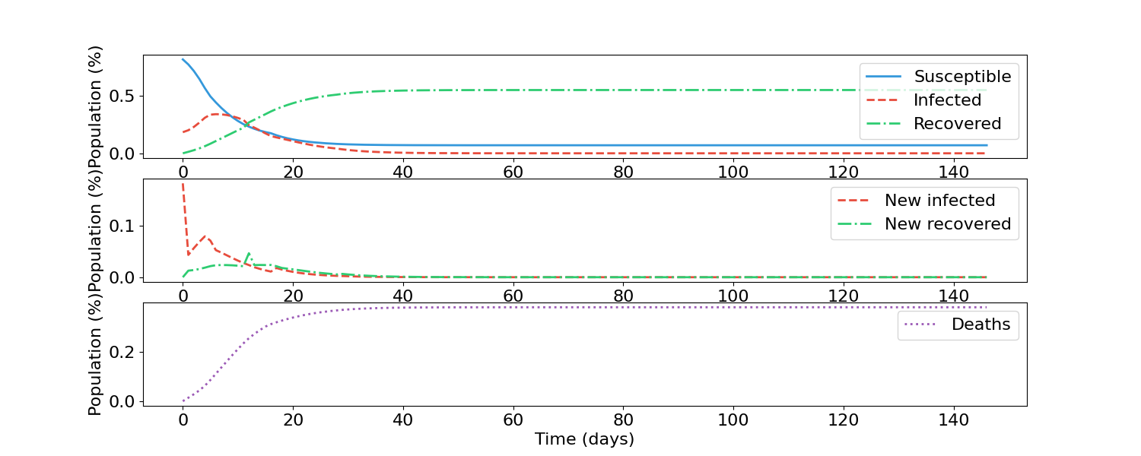

### 

### SIIRS (1.1.1)

Analysis:

For both the SIIR and SIIRS models, the fatalities are much higher than the base scenario. In the base scenario, the SIIR model has a final fatality population of 0.05 and for the SIIRS model about 0.5; compared to this modified scenario, where the original respective values are about 0.3 and 0.7, which are noticeable increases. This is expected as with a higher fatality rates, more people succumb to the disease.

## Increase in Fatalities for Elderly Population (1.2)

The fatalities of the most senior age group is 20x the base rate, the second-most elderly group 10x, and the third-most elderly group 2x. The full input file can be found in the attached file *ElderlyIncreasesFatality.py* .

### SIIRS (1.2.1)

### SIIRS (1.2.2)

Analysis:

Compared to the base scenario, fatalities have increases: for the SIIR model, from about 0.05 of the population to about 0.15; for the SIIRS model, 0.5 to 0.55. This is not as high of an increase as scenario 1.1 where all of the age groups had a increase in fatality of 10x. This result is expected though as only the more elderly population is now affected, and they do not represent the entire population.

# Recoveries (2)

## Increase in Recovery for All Age Groups (2.1)

The recovery rates for all age groups have been increased to 0.7, which is 10x more than the base rates. The full input file can be found in the attached file *AllIncreaseRecovery.py*.

### SIIR (2.1.1)

### SIIRS (2.1.2)

Analysis:

For the SIIR model, the pandemic lasts a short amount of time, from 120 days to 70, likely due to the infected recovering quickly enough to prevent spreading the disease to others. This results in less people getting infected and then recovering, hence the lower recovered population compared to the base scenario.

For the SIIRS model, the quick recovery rates ensure that the infected population remains small, and thus a low recovered population, all of which results in a large susceptible population.

In both models, the result of having a low infected population ensures that fatalities are lower than the base scenario.

## Younger Age Groups Recover More Quickly (2.2)

Compared to the base scenario: the youngest age group recovers 10x faster, the second youngest age group recovers 5x faster and the third youngest age group 2x faster. The input file can be viewed in the attached file *YoungRecoverQuicker.py .*

### SIIR (2.2.1)

### SIIRS (2.2.2)

Analysis:

Compared to the base scenario, there is less fatalities; for the SIIR model there is 0.025 instead of 0.050 and for SIIRS 0.3 instead of 0.5. Both of these are decreases that are easily visible on the graphs, and are expected as the faster people recover, the less time there are infected and can succumb to the disease.

Compared to the scenario in which all age groups have an increased recovery rates (2.1), the same trend holds but not to such a high degree. This is too is expected given that this scenario has changes in magnitude between the base scenario and scenario 2.1.

# Mobility (3)

## Increase in Mobility for All Age Groups (3.1)

All age groups, compared to the base scenario, are 1.5x more active. The full input file can be viewed in the attached file *AllMoreMobile*.py.

### SIIR (3.1.1)

### SIIRS (3.1.2)

Analysis:

For the SIIR model, there is a bigger wave of infection causing more people to get infected and subsequently recover. This also contributes to slightly more fatalities.

For the SIIRS model the same idea occurs; there are bigger waves of infections. Even past the 200 timestamp there are clear waves visible here, whereas this is not the case in the base scenario.

These results are understandable as the more people move around and interact with others, the more they are exposing themselves to potentially infected people. In doing so, there are periodic times in which enough people expose themselves to cause a noticeable uptick in infections.

## Adults More Mobile (3.2)

The second and fourth youngest age group is 1.25x more mobile than the base scenario, while the third youngest age group is 1.5x more mobile. This is due to the independence that adults have. The full input file can be viewed in the *AdultsMoreMobile.py* file.

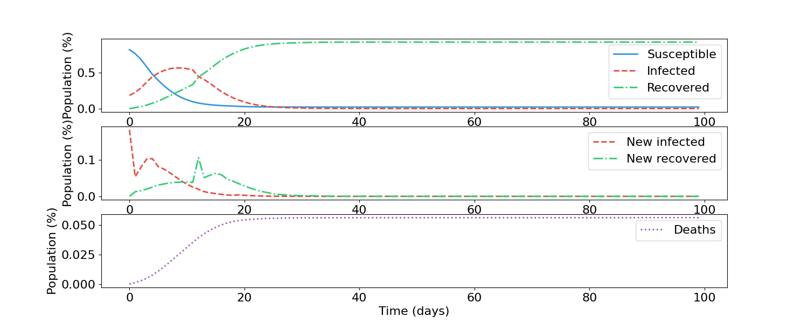SIIR (3.2.1)

### SIIRS (3.2.2)

Analysis:

Compared to Scenario 3.1 where all age groups were 1.5x more mobile, this scenario displays more muted changes seen in the aforementioned scenario. These changes are not the easiest to see and require a closer look to identify. This implies that having people more slightly mobile may not have as much of an impact as the other factors that influence a pandemic, such as the fatality rate or the recovery rate of the population.

# Virulence (4.0)

## Virus Is More Infectious For All Age Groups (4.1)

Compared to the base scenario, all age groups are 5x more infectious. The full input can be viewed in the attached file *AllMoreInfectious.py .*

### SIIR (4.1.1)

### SIIR(4.1.2)

Analysis:

The SIIR model shows a much larger infection wave, where the peak of infection hits approximately 0.75 of the population, whereas the base scenario is about 0.5. This results in the usual patterns of a larger infection wave (more fatalities, etc.)

The same pattern is seen in the SIIRS model as well, with much large infection peaks.

This is expected as a more infectious disease will be better at spreading even if mobility is reduced.

## Virus Is Less Infectious For All Age Groups (4.2)

All of the age groups are 5x less infectious than the base scenario. The input can be seen in the attached file *AllLessInfectious.py .*

### SIIR (4.2.1)

### SIIRS (4.2.2)

Analysis

For both the SIIR and SIIRS model, there is no definite wave of infection, and the number of people who do get infected is very small. As a result, both models display a very low amount of fatalities as well as a very high amount of susceptible population.

These results are expected as the less infectious a virus is, the less it will spread. Thus even if people go about their daily lives unchanged, the chance that they will become infected from a person with the virus is low.

## Absolute Lockdown with Hysteresis and Disobedient Population (5.0)

A lockdown in which all movement is prohibited when a certain infection threshold is reached, along with a hysteresis keeping the lockdown in effect even after the total infection population goes below the original amount. Note that there is a disobedient population. The disobedient population is 25% of the entire population. The full input for the SIIR model can be viewed in the file *AbsoluteLockDown_SIIR.py* and for SIIRS *AbsoluateLockDown_SIIRS*.py .

For both the SIIR and SIIRS model, the following scenarios will be used:

|  |  |  |
| --- | --- | --- |
| Lockdown Introduced At Total Infected Population | Hysteresis | Lockdown Lifted |
| 0.2 | 0.1 | 0.1 |
| 0.2 | 0.2 | 0.0 |
| 0.3 | 0.1 | 0.2 |
| 0.3 | 0.2 | 0.1 |
| 0.3 | 0.3 | 0.0 |

### SIIR (5.1)

*Lockdown at 0.2 Infected, Hysteresis: 0.1*

*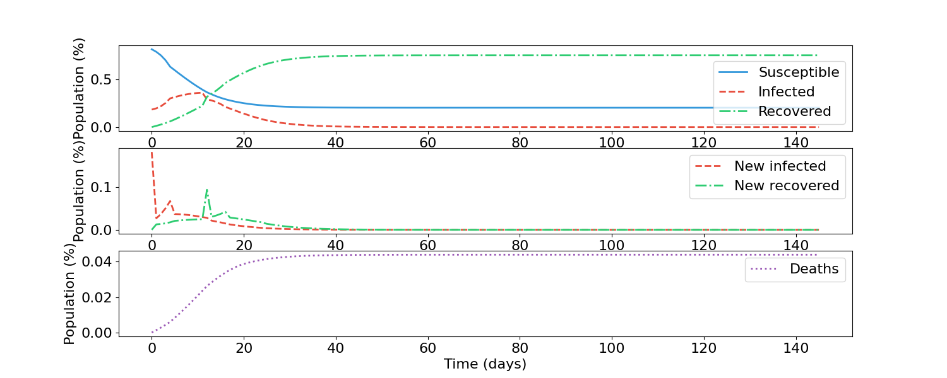Lockdown at 0.2 Infected, Hysteresis: 0.2*

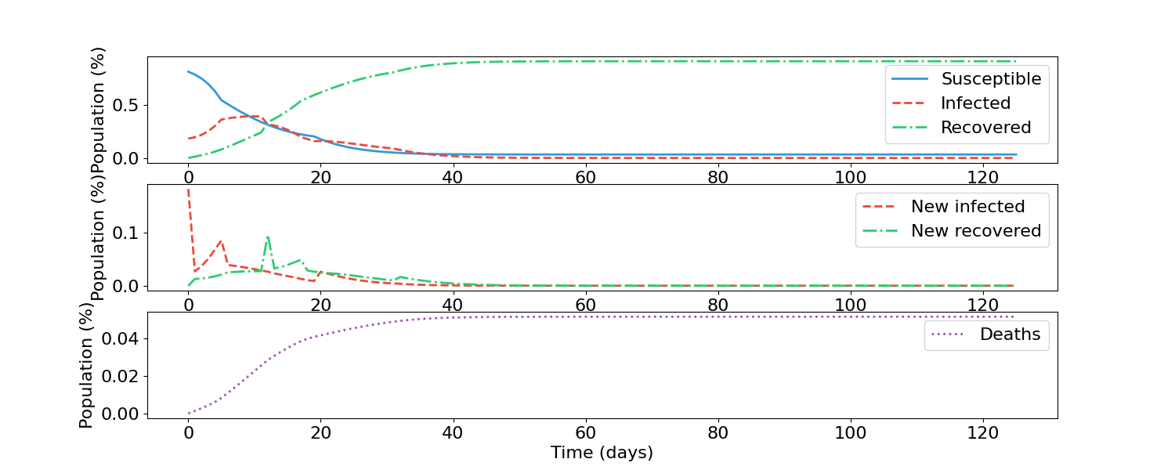

*Lockdown at 0.3 Infected, Hysteresis: 0.1*

*Lockdown at 0.3 Infected, Hysteresis: 0.2*

*Lockdown at 0.3 Infected, Hysteresis: 0.3*

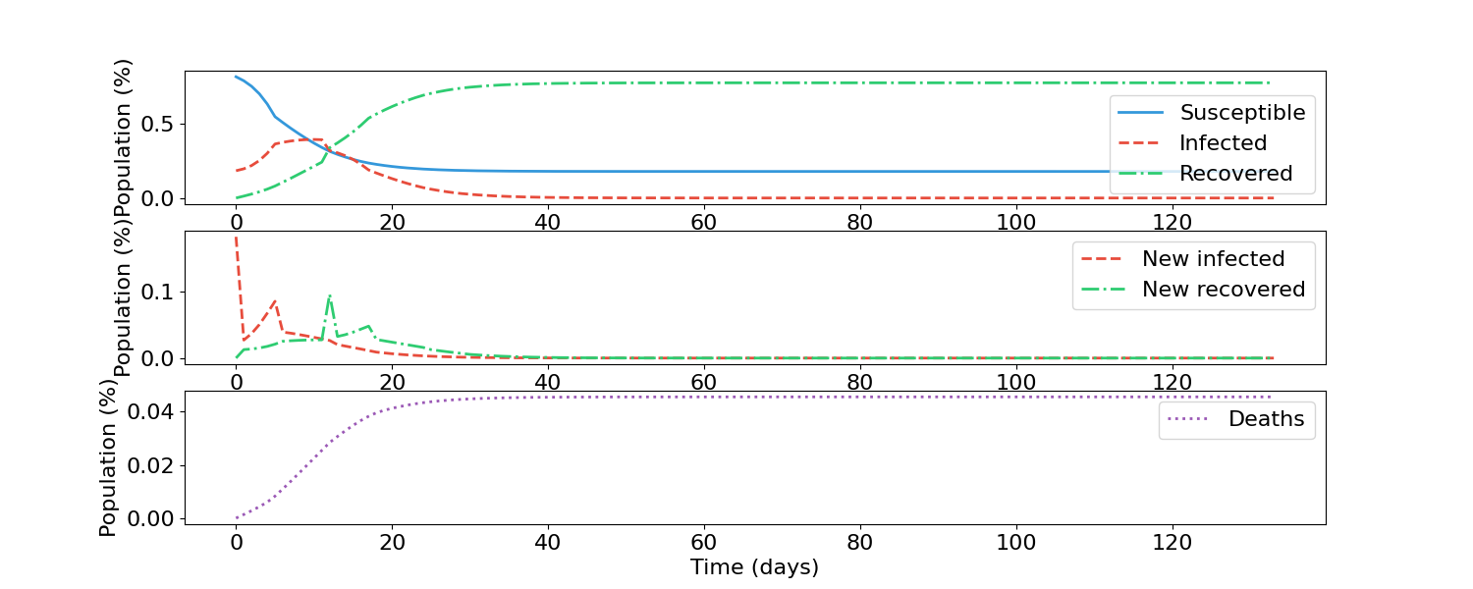

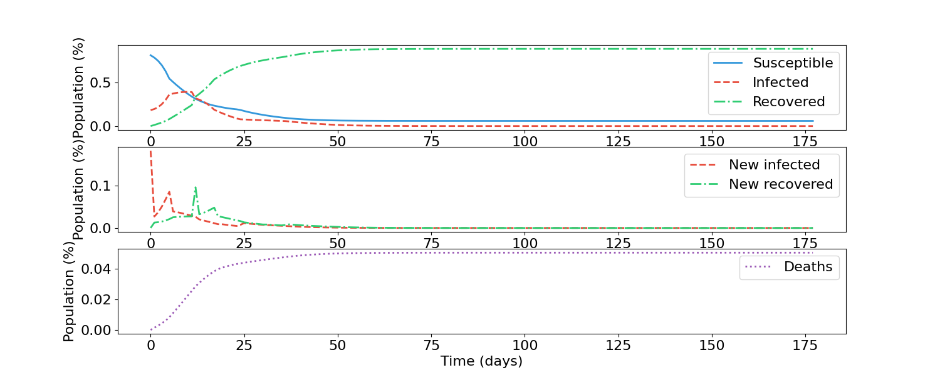

### SIIRS (5.2)

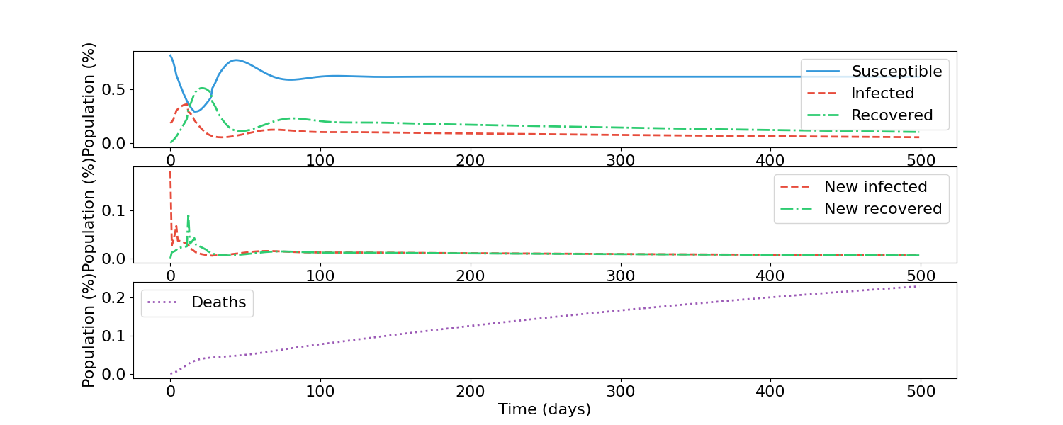*Lockdown at 0.2 Infected, Hysteresis: 0.1*

*Lockdown at 0.2 Infected, Hysteresis: 0.2*

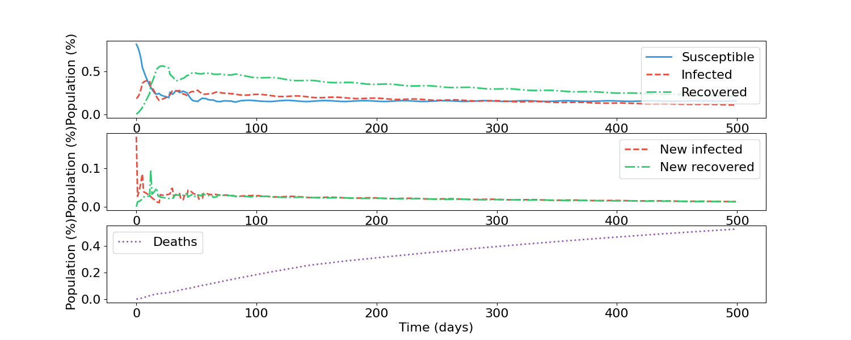

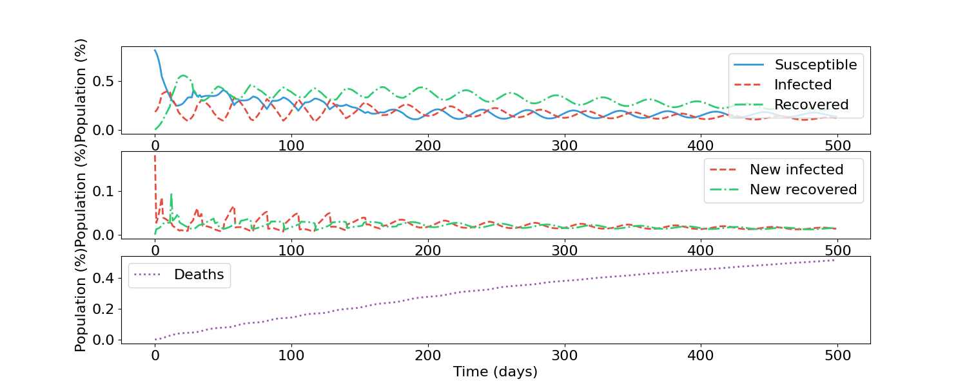*Lockdown at 0.3 Infected, Hysteresis: 0.1*

*Lockdown at 0.3 Infected, Hysteresis: 0.2*

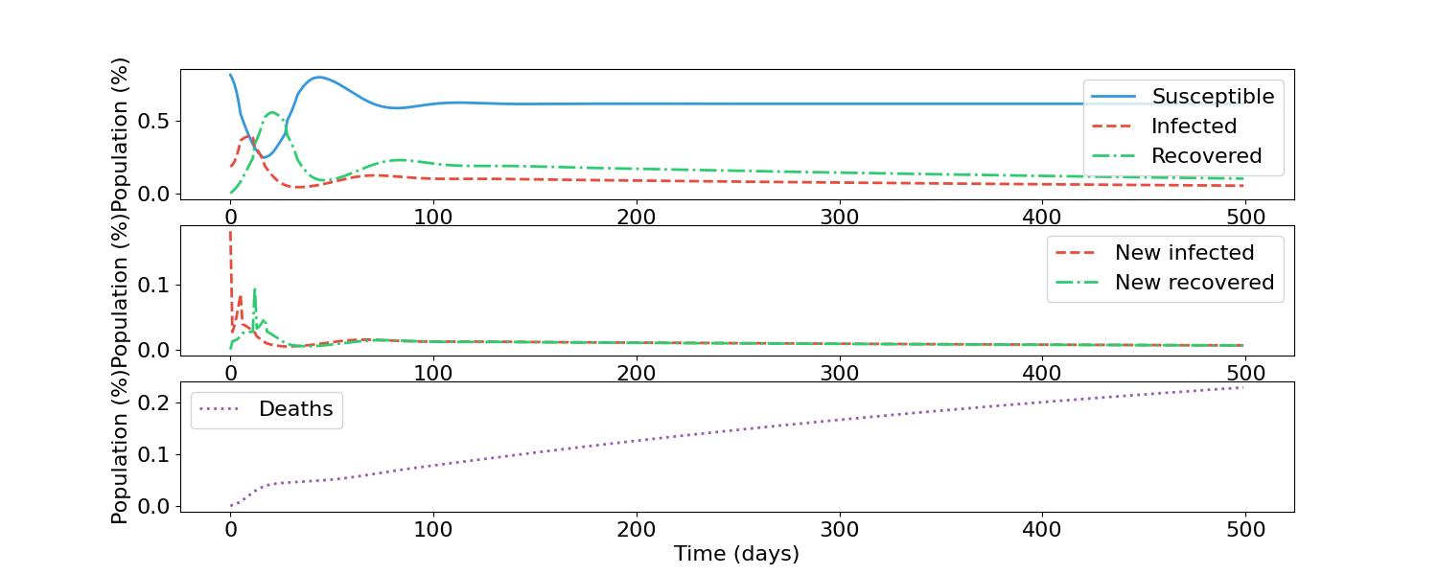

*Lockdown at 0.3 Infected, Hysteresis: 0.3*

Analysis

For the SIIR model, it can be seen that when the lockdown starts at a higher infected population that the infected population line, represented by line, starts to decline at higher value. Additionally, as the hysteresis increases, the downward trend following the introduction of the lockdown continues for longer. For example, in the lockdown starting at 0.3 with a hysteresis of 0.1, after the infection peak the infections drop by a small amount, but the downward trend of infections is not very consistent, whereas it is when the hysteresis is increased to 0.3.

For the SIIRS model, the same pattern can be seen, but the pattern repeats as well. The effect of these lockdown measures are most visible with a lockdown starting at 0.3 with hysteresis of 0.2. Every time the infected population reaches a value of 0.3, it immediately goes into a sharp decline until the infected population reaches 0.1. This shows that the lockdown is being applied and the hysteresis is ensuring that infections decrease by a noticeable amount before allowing the lifting of lockdown.

Notice that with a larger hysteresis and a lower initial lockdown starting point the fatalities are lowered; this is expected as the lockdowns reduce infections.

The fact that there are disobedient people means that the rate of infections will never reach zero once a lockdown is introduced, which is seen through all of the graphs.

# Absolute Lockdown with Hysteresis and No Disobedient Population (6.0)

A lockdown in which all movement is prohibited when a certain infection threshold is reached, along with a hysteresis keeping the lockdown in effect even after the total infection population goes below the original amount. Note that there is no disobedient population- everyone follows the lockdown imposed. The full input for the SIIR model can be viewed in the file *AbsoluteLockDown_SIIR_No_Disobedient.py* and for SIIRS *AbsoluateLockDown_SIIRS_No_Disobedient*.py .

For both the SIIR and SIIRS model, the following scenarios will be used:

|  |  |  |
| --- | --- | --- |
| Lockdown Introduced At Total Infected Population | Hysteresis | Lockdown Lifted |
| 0.2 | 0.1 | 0.1 |
| 0.2 | 0.2 | 0.0 |
| 0.3 | 0.1 | 0.2 |
| 0.3 | 0.2 | 0.1 |
| 0.3 | 0.3 | 0.0 |

### SIIR (6.1)

*Lockdown at 0.2 Infected, Hysteresis: 0.1*

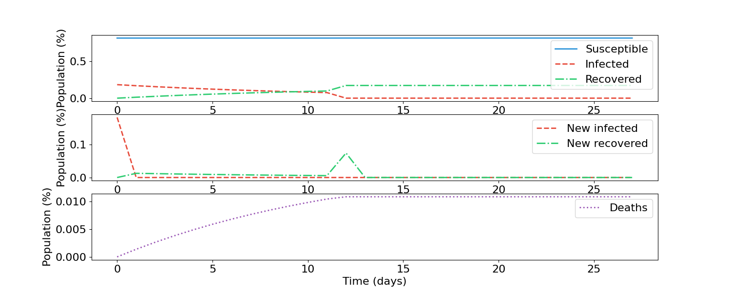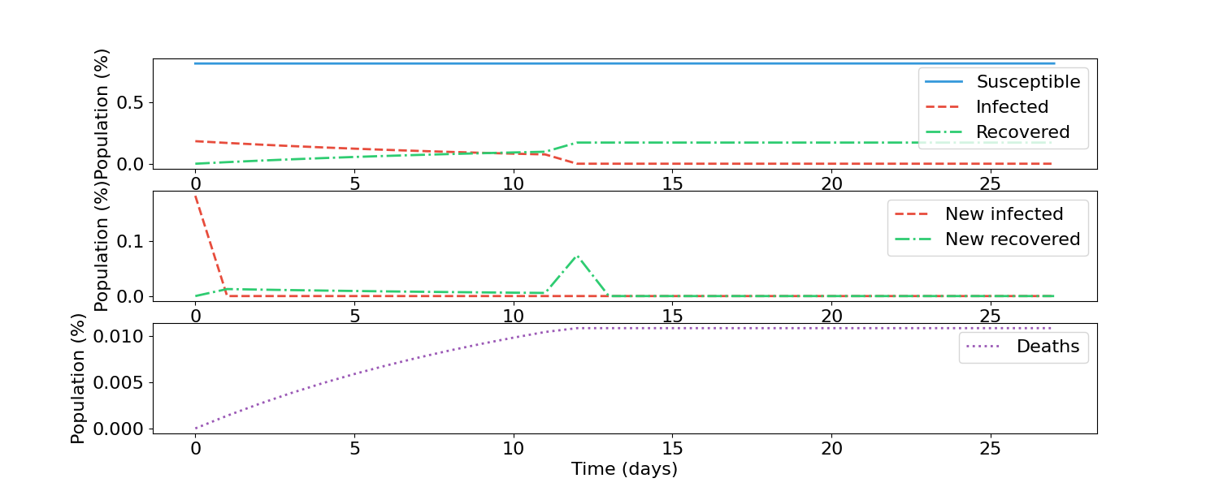*Lockdown at 0.2 Infected, Hysteresis: 0.2*

*Lockdown at 0.3 Infected, Hysteresis: 0.1*

*Lockdown at 0.3 Infected, Hysteresis: 0.2*

*Lockdown at 0.3 Infected, Hysteresis: 0.3*

### SIIRS (6.2)

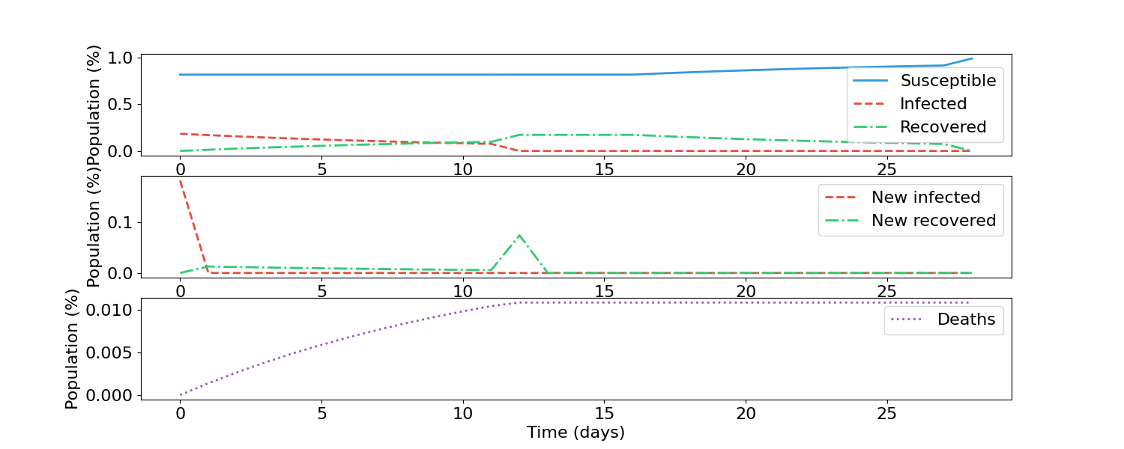*Lockdown at 0.2 Infected, Hysteresis: 0.1*

*Lockdown at 0.2 Infected, Hysteresis: 0.2*



*Lockdown at 0.3 Infected, Hysteresis: 0.1*

*Lockdown at 0.3 Infected, Hysteresis: 0.2*

**

*Lockdown at 0.3 Infected, Hysteresis: 0.3*

Analysis

For the SIIR model, it can be seen that with no disobedient population, once the lockdown is imposed the mobility of the population is reduced to the point that the pandemic cannot keep going. This is also confirmed by the shorter pandemic period compared to the base scenario (25 days instead of 120) and the lower fatality rates. Having a compliant population also removes the need for hysteresis, as the graphs remain the same regardless of the hysteresis value (assuming that the lockdown starts at the same infected population).

The graphs of the SIIRS model deserve an explanation as to why they are similar to the SIIR model. The reasoning is as follows: the initial infected population of a single cell is the above the infection threshold and thus is in; the neighboring cells do not start with any infected population. Thus there is no movement between the infected cell and the neighbouring cells, as well as within the infected neighbor itself. By the time the infectious cell has an infected population below the lockdown threshold, all infected persons have recovered.

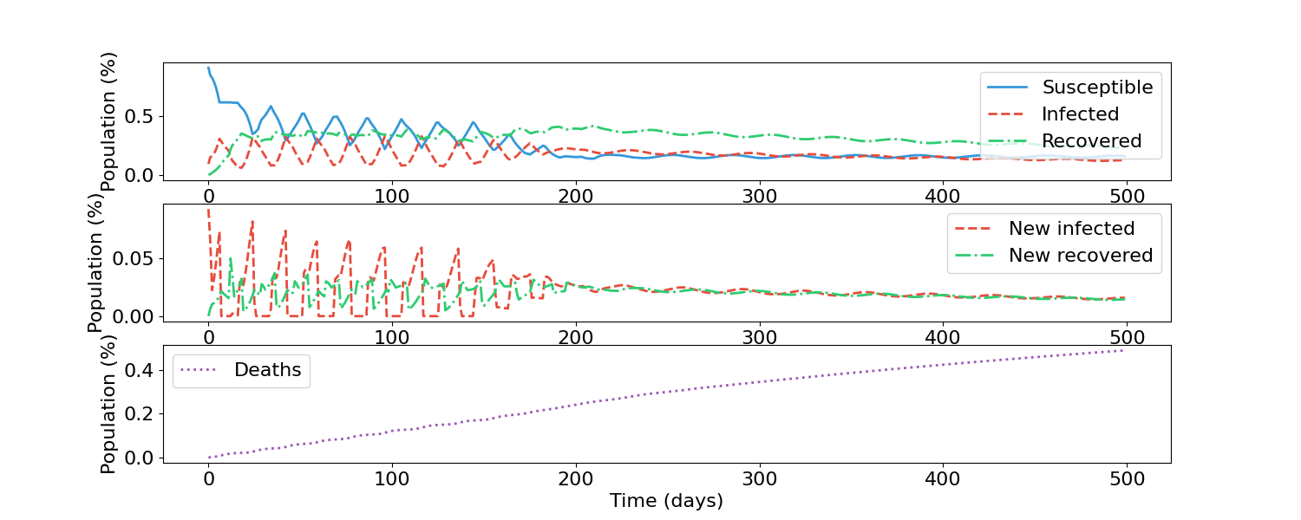In order to show a situation in which there is neighbor-to-neighbor infection but periods of no infection due to a lockdown, another scenario is given below: an lockdown starting at 0.3 infected population with a hysteresis of 0.2, but a smaller initial infected population. This allows for new infections before a lockdown occurs, allowing the pattern of lockdown + hysteresis to be shown. Here it can be seen that as soon as the infected population reaches 0.3, there are no new infections until total infections goes below 0.1.

# Hospital Infected Capacity (7.0)

## Lower Infected Capacity (7.1)

The capacity of hospitals drop from 0.2 to 0.0, signifying a complete collapse of the medical system. The input can be seen in the attached file *LessHospitalCapacity.py .*

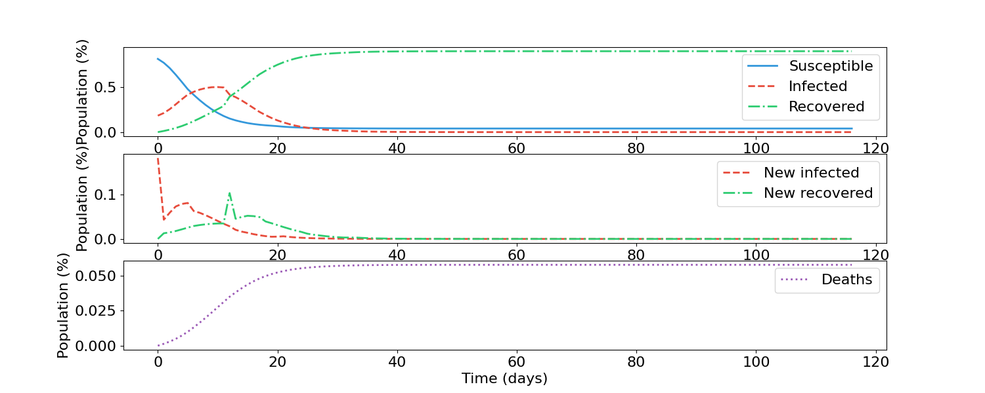SIIR (7.1.1)

### SIIRS (7.1.2)

Analysis:

For both SIIR and SIIRS, it can be seen that when the hospital capacity is lowered to 0.0- signifying a complete collapse of the healthcare system- the fatalities are higher. This is expected as hospitals increase the chances of survival, and so where they are not available those that would otherwise survive with medical aid end up succumbing to the disease.

## Higher Hospital Capacity (7.2)

The capacity of hospitals increases from 0.0 to 0.8, signifying a robust medical system. The input can be seen in the attached file *LessHospitalCapacity.py .*

### SIIR (7.2.1)

### SIIRS (7.2.2)

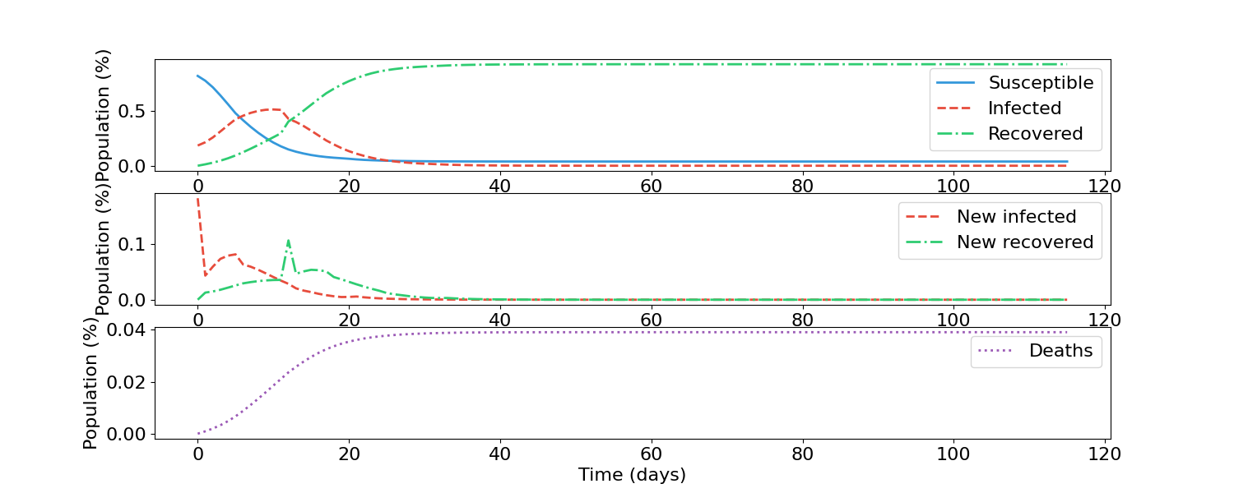Analysis:

On the other hand, raising the capacity to 0.8 where a large amount of infected people can be treated, reduces fatalities. This is also expected as a medical system which can treat more people can save those that would have died if they do not get any medical care.

# Fatality Modifier (8.0)

## Lower Fatality Modifier (8.1)

The fatality modifier if hospitals are overwhelmed is decreased from 1.5 to 1.0. Thus there is no difference to the fatality rate if hospitals are overwhelmed. The input can be seen in the attached file *LowerFatalityModifier.py .*

### SIIR (8.1.1)

### SIIRS (8.1.2)

Analysis:

For both SIIR and SIIRS, it can be seen that if the fatality modifier is 1.0, there is no penalty to having hospitals overwhelmed, resulting in a smaller amount of fatalities. It should be noted that that this difference is quite small to be noticeable in the graphs, meaning that in the base scenario having hospitals overwhelmed was not a big contributor to fatalities. Meanwhile increasing the fatality modifier to make the disease 10x more deadly if overwhelmed results in more fatalities.

## Higher Fatality Modifier (8.2)

The fatality modifier if hospitals are overwhelmed is decreased from 10.0 to 1.0. Thus there is a very large difference to the fatality rate if hospitals are overwhelmed. The input can be seen in the attached file *HigherFatalityModifier.py .*

### SIIR (8.2.1)

### SIIRS (8.2.2)

Analysis:

For both SIIR and SIIRS, it can be seen that if the disease requires medical intervention in order to have low fatality rates, then having the hospitals become overwhelmed noticeable increases deaths. This is seen in the above charts where, for example, the fatalities for the SIIRS model surpasses 0.5 by a visible margin while in the base scenario in does not.

# Disobedience (9.0)

## Lower Disobedience (9.1)

The disobedience is reduced to 0, meaning that all people are listening to lockdown rules. An earlier example where the disobedience value was also zero- the difference here is that there is no absolute lockdown, using the same lockdown thresholds as in the base scenario. The input can be seen in the file *LowerDisobedience_SIIR.py.*

### SIIR (9.1.1)

### SIIRS (9.1.2)

Analysis:

Having everyone obey the lockdown rule results in a lower amount of infections and thus fatalities. For example, in the first peak of infections for the SIIRS model, the base scenario reaches 0.5 of the population infected, whereas in Figure 9.1.2 the first peak does not remotely approach 0.5. This is expected- the more people are following lockdown the less interaction there between people.

## Higher Disobedience (9.2)

The disobedience is increased to 1.0, meaning that all people are not listening to lockdown rules. The input can be seen in the file Higher*Disobedience_SIIR.py.*

### SIIR (9.2.1)

### SIIRS (9.2.2)

Analysis:

With everyone ignoring lockdown, there are much more infections, resulting in more fatalities. For example, the fatalities for the SIIR model noticeably rises above the 0.0050 mark. This real change though is with the SIIRS model- with everyone ignoring lockdown, effectively making them non-existent, there are continuous waves of infections. In the base scenario these waves die out at around the 300 time mark, whereas in the above mark these waves are still clearly visible. This is expected as lockdowns are meant to lower infection; if they have no effect then the pandemic will have periodic peaks of infections as people continuously become infected, recover and then become susceptible again.

# Change of Number of Infection Stages (10.0)

## Lower Number of Infection Stages (10.1)

The number of infection stages is lowered from 12 in the base scenario to 6. The full input can be viewed in the file *LessInfectionPhases.py*.

### SIIRS (10.1.1)

### SIIRS (10.1.2)

Analysis:

Both the SIIR and SIIRS model show less infections and subsequently less fatalities compared to the base version. The SIIRS model fatalities is reduced from near 0.45 to around 0.25; the SIIR model from 0.050 to about 0.020. These changes are expected as fewer infection stages means that people move out of the infection stages quicker and thus less time spent being infected. With less time spent being infected, there will be less fatalities and a higher proportion of the population being in a non-infected state.

## More Infection Stages (10.2)

The number of infection stages is increased from 12 in the base scenario to 24. The full input can be seen in the file *MoreInfectionStages.py.*

### SIIR (10.2.1)

### SIIRS (10.2.2)

Analysis:

The pattern change is the opposite of the scenario where the number of infection stages are reduced. Here, the number of infected individuals is always higher compared to the base scenario, resulting in many more deaths (SIIR: from ~0.050 to ~0.075; SIIRS: from ~0.045 to ~0.6). This is also expected; the more time that a person is infected, the bigger chance that they will succumb to the disease. Additionally, having more people in an infected stage lowers the susceptible population such that waves of infection are not as big of a presence; the SIIRS model has two distinct infection waves (time = 0 and time = 50) whereas the base scenario has a more noticeable waves at later points in time.

# Change of Number of Recovery Phases (12)

## Less Number of Recovery Phases (12.1)

The number of recovery phases is reduced from 16 in the base scenario to 8. The full input can be seen in the file *LessRecoveryPhases.py .*

### SIIR (12.1.1)

### SIIRS (12.1.2)

Analysis:

The SIIR graph does not show a visible change compared to the base scenario. This can be explained by the fact that in the SIIR model, the recovery is last step of the state, meaning that once a person enters it, it they are considered in that state forever, regardless of how many phases are in that state there actually are. Thus changing the number of recovery phases in this model has no effect.

The SIIRS model shows less waves compared to the base model. This is due to the fact that people being immune for a shorter period of time means there is constant supply of susceptible peple to become infected. There is also showed by the fact that the susceptible population is clearly larger than the infected and recovered population at the 500 time mark, where is not the case in the base scenario. Additionally, there is a noticeable larger increase in fatalities, which makes sense if people can become infected again more quickly (fatality here is ~0.55 versus 0.45 in the base scenario).

## More Recovery Phases (12.2)

The number of recovery phases is increased from 16 in the base scenario to 32. The full input can be seen in the file *MoreRecoveryPhases.py .*

### SIIR (12.2.1)

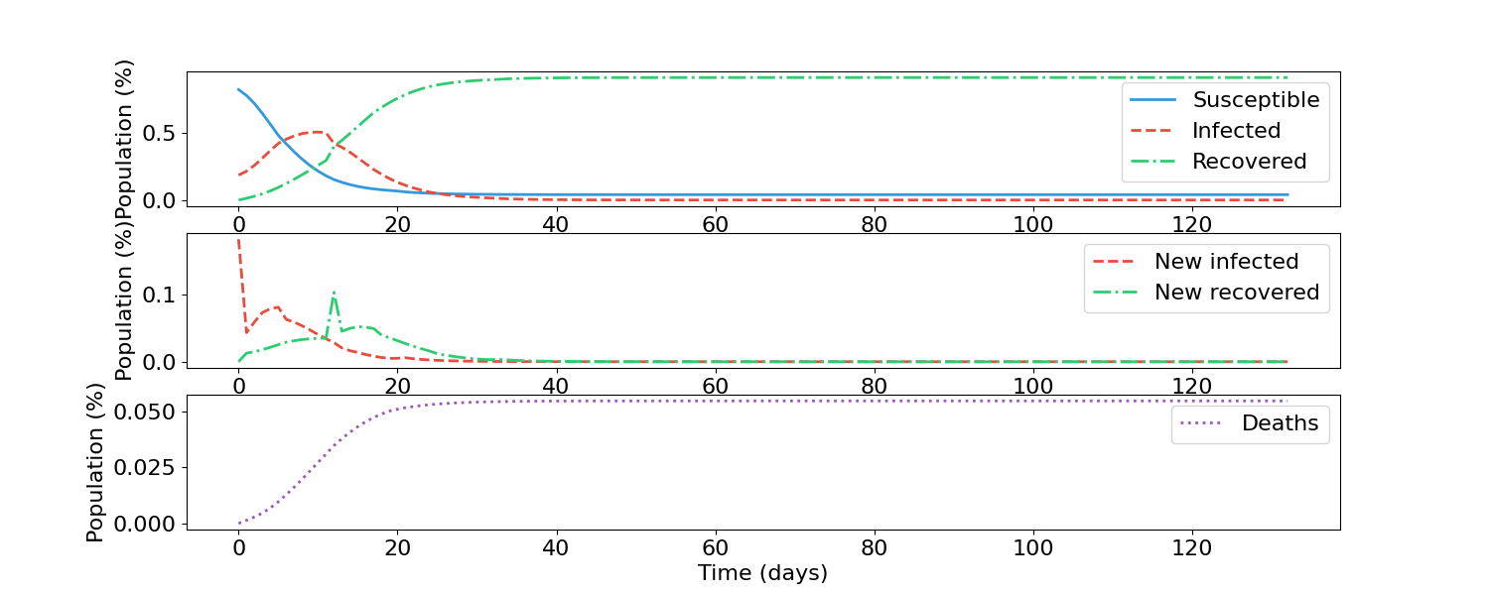

### SIIRS (12.2.2)

Analysis:

For the SIIR model, the lack of change is explained in the scenario with less recovery phases (12.1).

For the SIIRS graph, there are much more noticeable waves of infection. Even pass the 400 time mark, there are clear waves. This is explained by the fact that with a longer recovery/immune time, the time for a susceptible population takes longer to build up. While it does, there is the susceptible population is not large enough to cause a wave. The longer time spent being immune to the disease also explains the lower fatality rate (maximum of 0.4 versus ~0.45 in the base model)

# Change of Neighbor Correlation (13)

## Smaller Correlation (13.1)

The correlation of the neighbor cells is changed from the range of 0.5 – 0.7 to a flat 0.1, indicating the neighboring cells are less connected to each other. The input can be seen in the file *LessCorrelatedNeighbours.py*.

### SIIR (13.1.1)

### SIIRS (13.1.2)

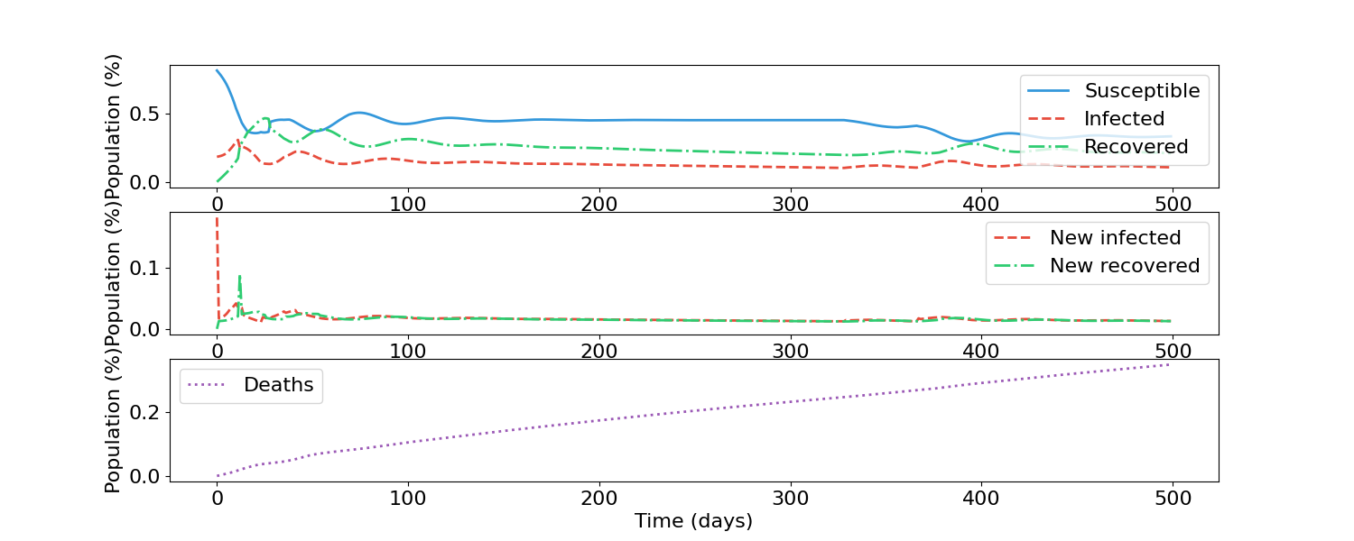

Analysis:

Both models exhibit a smaller rate of infection and subsequently fatalities. For the SIIRS model the fatalities do not exceed 0.4 whereas in the base scenario the fatality number at the 500 time mark was about 0.045. For the SIIR model, 0.0045 instead of 0.0050. This is explained by the fact that having less correlation between cells means less movement between them as well. As a result, there is less chance for infected people from one cell to travel to a different cell and infect those in the other cell. This slows the rate of new infections which in the long run reduces the amount of total infections.

## Higher Correlation between Cells (13.2)

The correlation of the neighbor cells is changed from the range of 0.5 – 0.7 to a flat 1, indicating the neighboring cells are more connected to each other. The input can be seen in the file Higher*CorrelatedNeighbour.py* .

### SIIR (13.2.1)

### SIIRS (13.2.2)

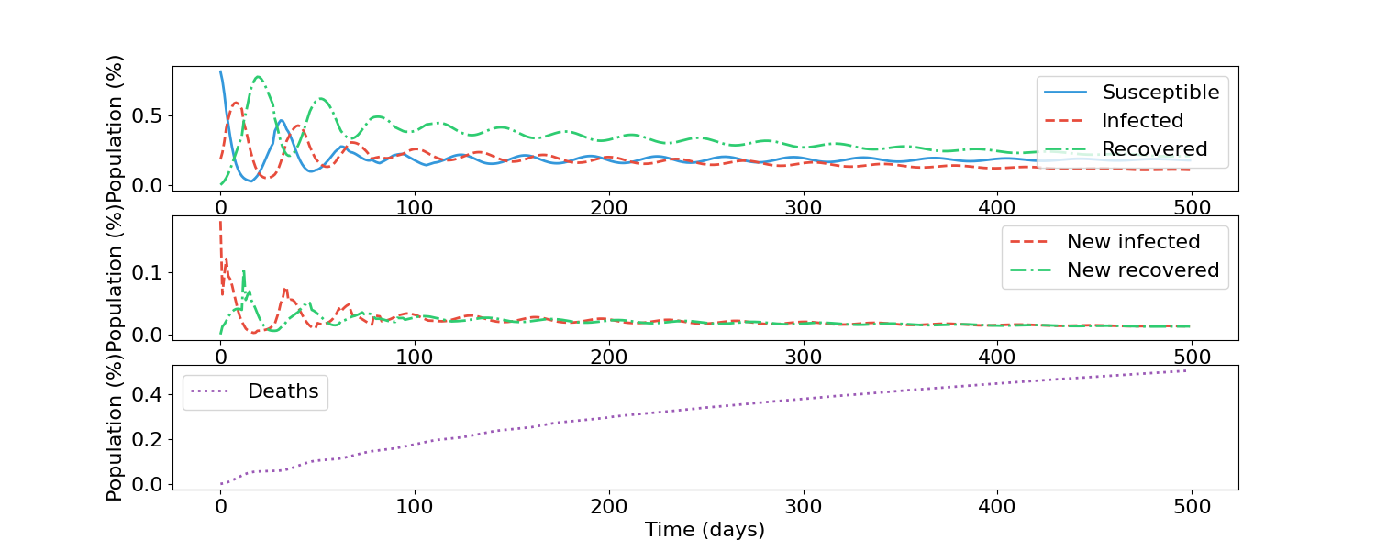

Analysis:

The pattern seen here is the opposite of what was seen when the correlation between neighboring cells was reduced. Instead of a smaller infection rate, there is a larger one, and that in the SIIRS model, produces larger waves of infection. The fatality rates for both models are also slightly larger (~0.06 instead of ~0.050 for the SIIR model; for the SIIRS model- ~0.5 instead of ~0.45).

These changes are expected as the more connected two cells are, the easier it is to move between them. Thus infected people from one cell are more likely to infect others in different cells, increasing access to a larger pool of susceptible people to infect and thus more infections, as seen especially with the SIIRS model. (For example, in the SIIRS model, the first infected peak goes well beyond 0.5; in the base scenario, the value does not exceed 0.5).

# Ontario Simulations (14.0)

Note: The input files are too large to be included with this document. The parameters to run the below scenarios are the same as the respective base versions, just with Ontario cells.

The analysis for the below graphs can be seen with the respective base versions.

## Base Scenario (14.1)

### SIIR (14.1.1)

### SIIRS(14.1.2)

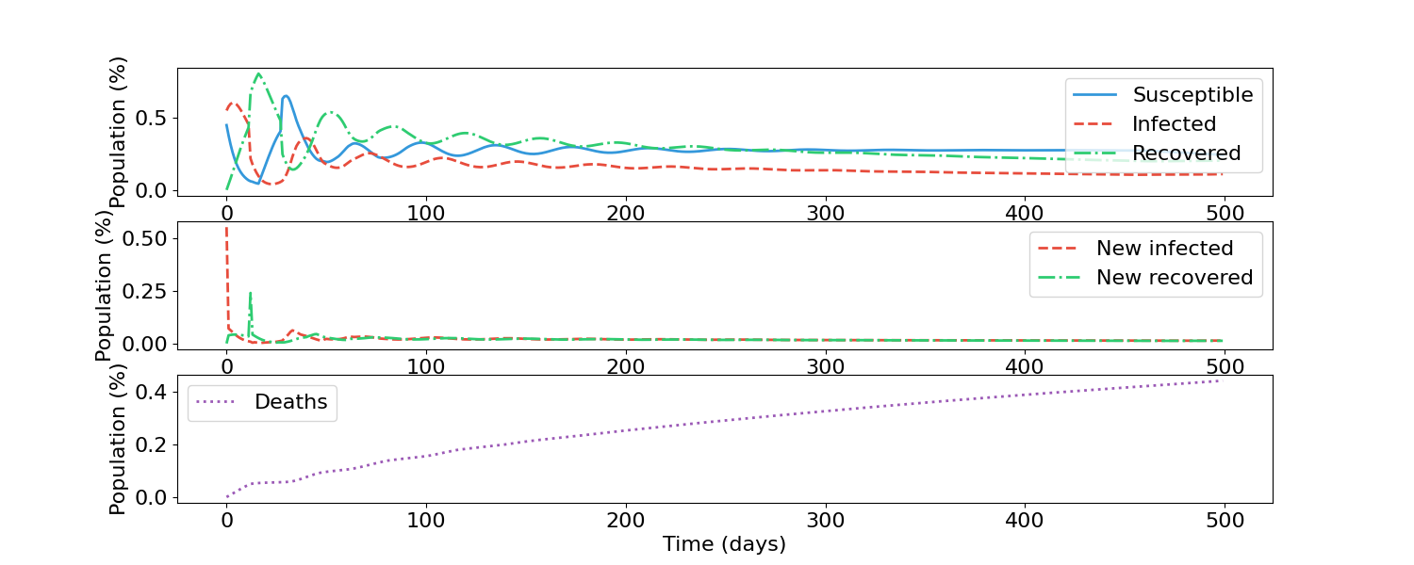

## Higher Fatality (14.2)

### SIIR(14.2.1)

### SIIRS(14.2.2)

## Higher Recovery (14.3)

### SIIR (14.3.1)

### SIIRS(14.3.2)

## More Recovery Phases (14.4)

### SIIR(14.4.1)

### SIIRS(14.4.2)

## Absolute Lockdown with Hysteresis with No Disobedient Population (14.5)

### SIIR(14.5.1)

### SIIRS (14.5.2)

**Table of Contents**

Base Scenario 1

SIIR 1

SIIRS 1

Fatalities (1.0) 2

Increase in Fatalities for All Age Groups (1.1) 2

SIIRS (1.1.0) 2

SIIRS (1.1.1) 2

Increase in Fatalities for Elderly Population (1.2) 3

SIIRS (1.2.1) 3

SIIRS (1.2.2) 3

Recoveries (2) 4

Increase in Recovery for All Age Groups (2.1) 4

SIIR (2.1.1) 4

SIIRS (2.1.2) 4

Younger Age Groups Recover More Quickly (2.2) 5

SIIR (2.2.1) 5

SIIRS (2.2.2) 5

Mobility (3) 6

Increase in Mobility for All Age Groups (3.1) 6

SIIR (3.1.1) 6

SIIRS (3.1.2) 6

Adults More Mobile (3.2) 7

SIIR (3.2.1) 7

SIIRS (3.2.2) 7

Virulence (4.0) 8

Virus Is More Infectious For All Age Groups (4.1) 8

SIIR (4.1.1) 8

SIIR(4.1.2) 8

Virus Is Less Infectious For All Age Groups (4.2) 9

SIIR (4.2.1) 9

SIIRS (4.2.2) 9

Absolute Lockdown with Hysteresis and Disobedient Population (5.0) 10

SIIR (5.1) 10

SIIRS (5.2) 13

Absolute Lockdown with Hysteresis and No Disobedient Population (6.0) 16

SIIR (6.1) 16

SIIRS (6.2) 18

Hospital Infected Capacity (7.0) 21

Lower Infected Capacity (7.1) 21

SIIR (7.1.1) 21

SIIRS (7.1.2) 21

Higher Hospital Capacity (7.2) 22

SIIR (7.2.1) 22

SIIRS (7.2.2) 22

Fatality Modifier (8.0) 23

Lower Fatality Modifier (8.1) 23

SIIR (8.1.1) 23

SIIRS (8.1.2) 23

Higher Fatality Modifier (8.2) 24

SIIR (8.2.1) 24

SIIRS (8.2.2) 24

Disobedience (9.0) 25

Lower Disobedience (9.1) 25

SIIR (9.1.1) 25

SIIRS (9.1.2) 25

Higher Disobedience (9.2) 26

SIIR (9.2.1) 26

SIIRS (9.2.2) 26

Change of Number of Infection Stages (10.0) 27

Lower Number of Infection Stages (10.1) 27

SIIRS (10.1.1) 27

SIIRS (10.1.2) 27

More Infection Stages (10.2) 28

SIIR (10.2.1) 28

SIIRS (10.2.2) 28

Change of Number of Recovery Phases (12) 29

Less Number of Recovery Phases (12.1) 29

SIIR (12.1.1) 29

SIIRS (12.1.2) 29

More Recovery Phases (12.2) 30

SIIR (12.2.1) 30

SIIRS (12.2.2) 30

Change of Neighbor Correlation (13) 31

Smaller Correlation (13.1) 31

SIIR (13.1.1) 31

SIIRS (13.1.2) 31

Higher Correlation between Cells (13.2) 32

SIIR (13.2.1) 32

SIIRS (13.2.2) 32

Ontario Simulations (14.0) 34

Base Scenario (14.1) 34

SIIR (14.1.1) 34

SIIRS(14.1.2) 34

Higher Fatality (14.2) 35

SIIR(14.2.1) 35

SIIRS(14.2.2) 35

Higher Recovery (14.3) 36

SIIR (14.3.1) 36

SIIRS(14.3.2) 36

More Recovery Phases (14.4) 37

SIIR(14.4.1) 37

SIIRS(14.4.2) 37

Absolute Lockdown with Hysteresis with No Disobedient Population (14.5) 38

SIIR(14.5.1) 38

SIIRS (14.5.2) 38